SAICM
Quick Start Programme Trust Fund

I

Funding Application Form

For Office Use Only
Project No:
Applicant* |  | For Office Use Only  Project No:
√
Government Civil society network (Non-governmental organization)

Applicant organization / institution: PRO-BIODIVERSTY CONSERVATIONITS IN UGANDA (PROBICOU).
Applicant representative: MR. TUMWESIGYE ROBERT
Functional Title: CO-ORDINATOR
Section / Department: CHEMICALS MANAGEMENT
Address: PLOT 181 BOMBO ROAD, P.O. BOX 34407 KAMPALA
Phone: +256-414-532676
Fax:
E-Mail: probicon@probiodiversity.org/tumwesigeus@yahoo.com
Website address (if available): www.probiodiversity.org
*Applicants are reminded that applications should all be endorsed by the SAICM national focal point for the country (or countries) where the project will be executed. Civil society applications should, in addition, be endorsed and submitted by a SAICM NGO focal point. Note: A project applicant is also referred to as a “project proponent” in the application form and guidelines.

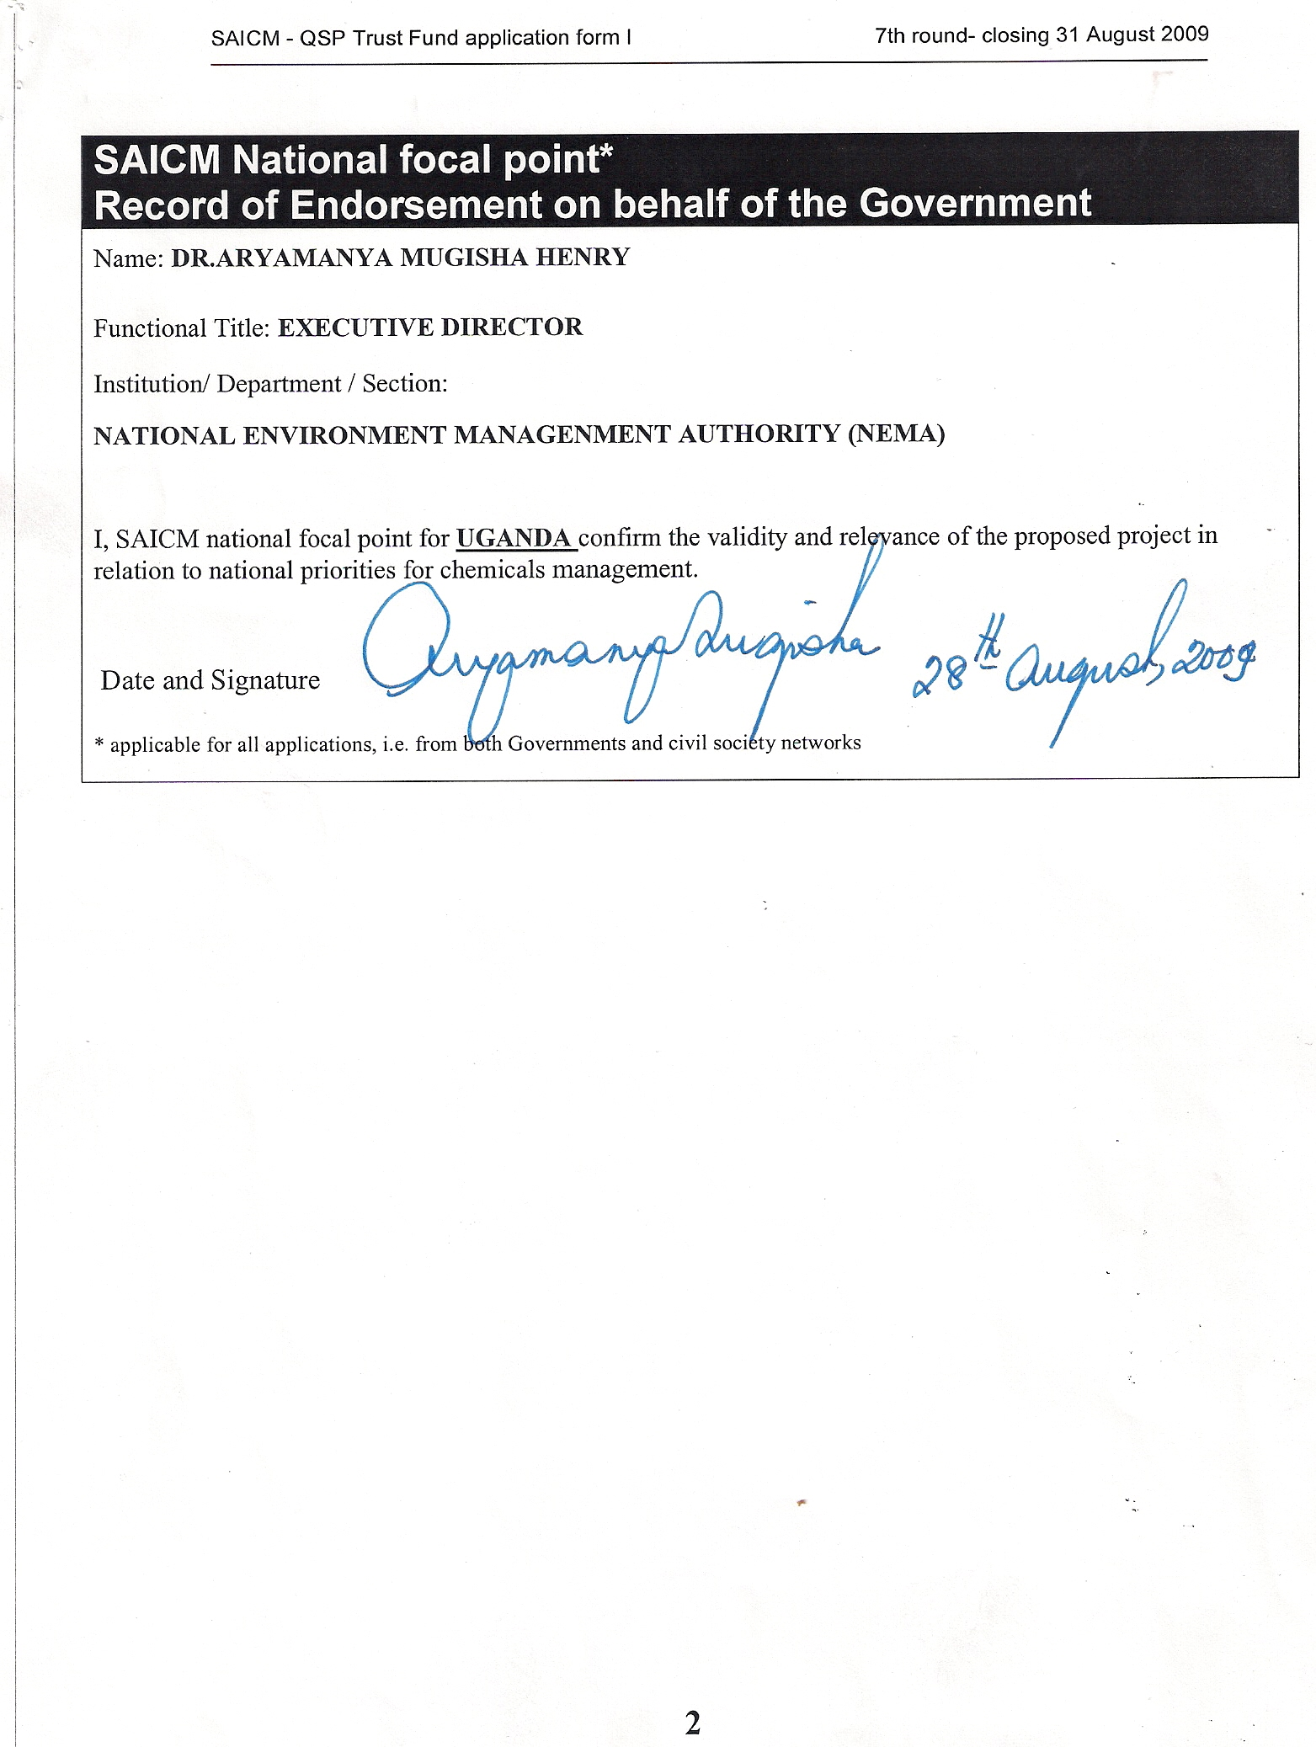
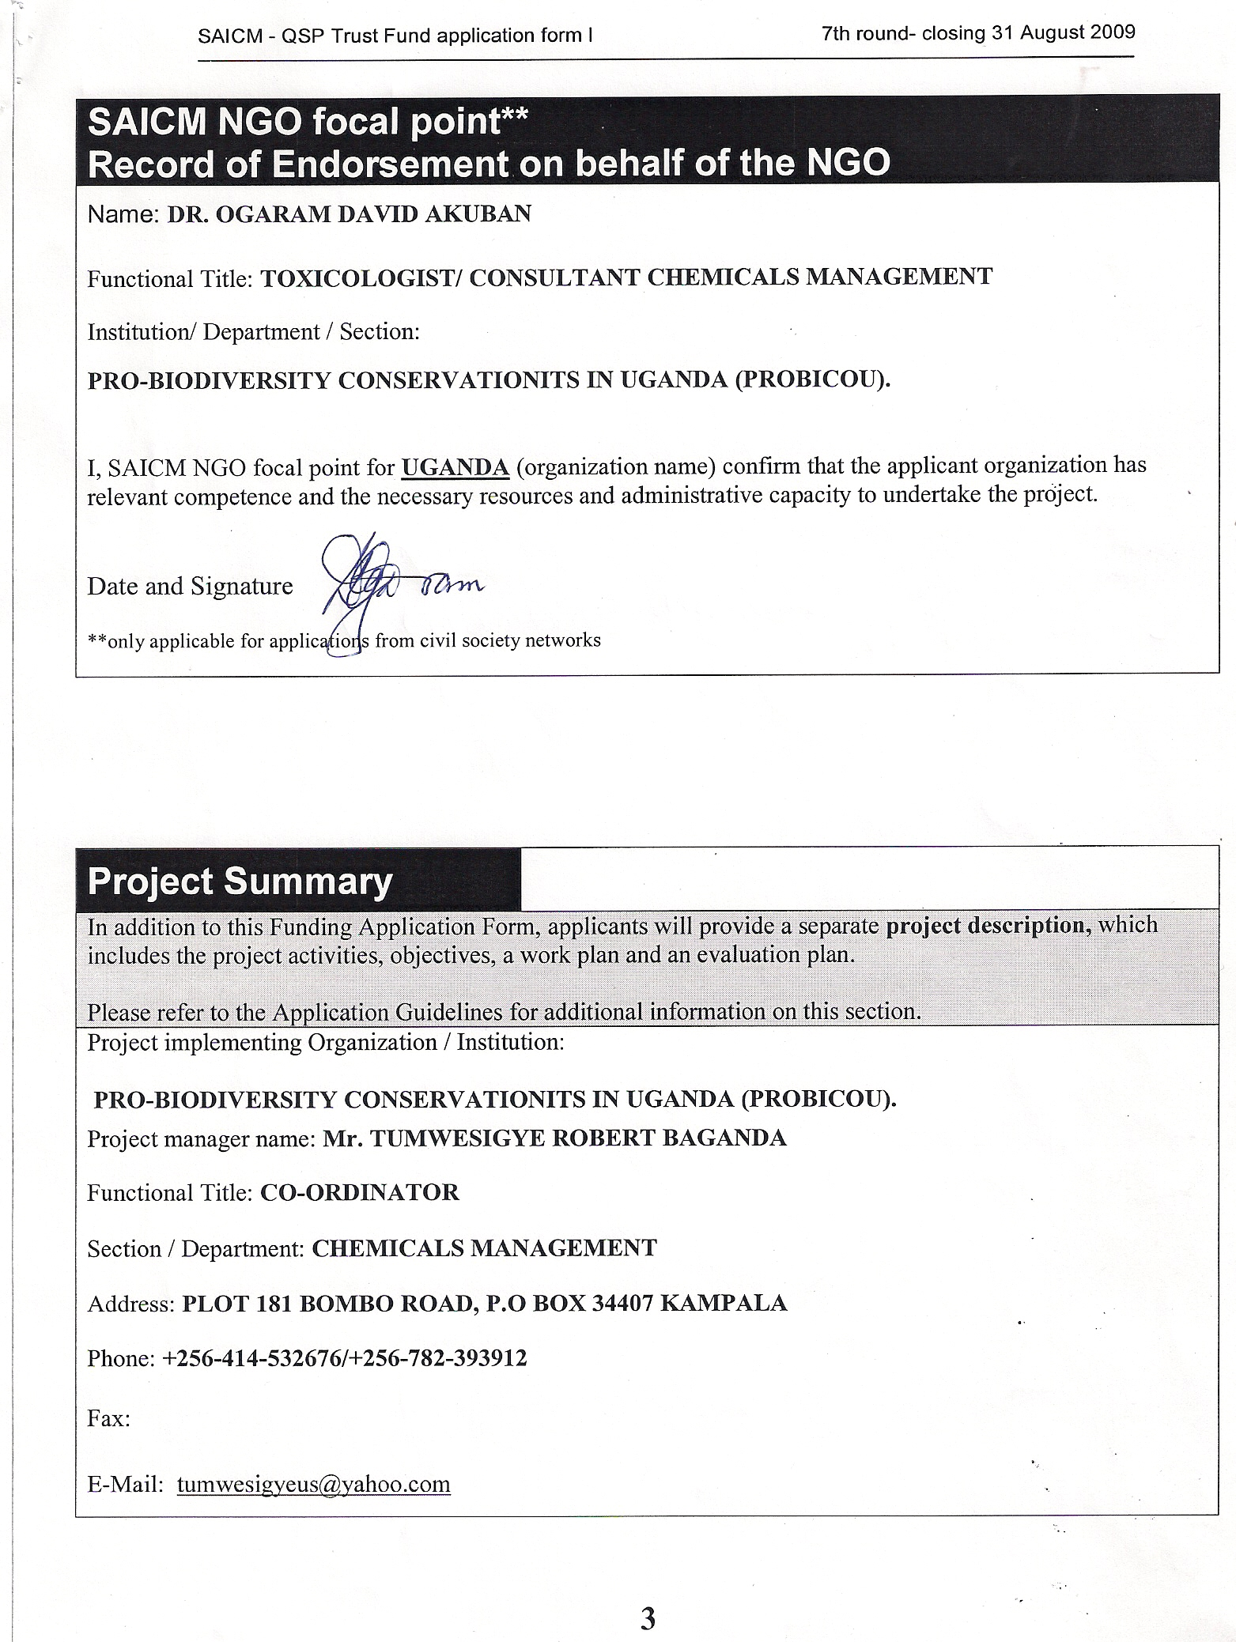

Project Summary
In addition to this Funding Application Form, applicants will provide a separate project description, which includes the project activities, objectives, a work plan and an evaluation plan.

Please refer to the Application Guidelines for additional information on this section.
Project implementing Organization / Institution:

PRO-BIODIVERSITY CONSERVATIONITS IN UGANDA (PROBICOU).
Project manager name: Mr. TUMWESIGYE ROBERT BAGANDA
Functional Title: CO-ORDINATOR
Section / Department: CHEMICALS MANAGEMENT
Address: PLOT 181 BOMBO ROAD, P.O BOX 34407 KAMPALA
Phone: +256-414-532676/+256-782-393912
Fax:
E-Mail: tumwesigyeus@yahoo.com
Project Title: PROMOTING CHEMICAL SAFETY FOR CHILDREN AT WORK IN RURAL AGRICULTURAL COMMUNITIES.
Geographical coverage of the project : COUNTRYWIDE
Sectoral coverage of the project:
Agriculture Environment Health Labour Multisectoral Other sector

The project will be multi-sectoral and will cover mainly the sectors of Agriculture, environment, labour and health.
Duration: 24 Months
Commencing (date): May 2010
Ending (date): May 2012
Outline of the project :

Introduction
Child labour exists in Uganda. One countrywide form of child labour is the use of children in agriculture. In this sector, children are involved in application of pesticides and other agricultural chemicals. Exposure of children to toxic chemicals is an aspect of the worst forms of child labour as far as Uganda is concerned.

This project is an effort to put in place a minimal programme to prevent ill health arising from pesticides with particular focus on children at work in agricultural setting. The project focuses on: - developing an up-to-date information on chemicals in agriculture, their uses, the dangerous processes and end point discharges; developing manpower among the workers, employers and the general public for the dissemination of safety measures in use of toxic chemicals; and building a comprehensive public awareness and education on the alternatives to toxic chemicals and careful use when it is necessary to use them.

The key strategy is risk reduction, risk assessment, characterisation and management. Correspondingly, the main thrust of the effort is capacity building with a view to strengthen the horizontal and vertical institutional inter-phases for the management of agricultural chemicals and employment of children in their use. This is to be done though coordination, awareness, advocacy, training, and equipping the participating institutions. In particular:

- Setting up a coordination mechanism to enable all the stakeholders to effectively participate in elimination of exposure of children to chemical hazards;

- Mobilising the communities, the workers, the employers and the general public, through awareness campaigns, to remove children from handling dangerous chemicals and create the necessary awareness and respect for such chemicals;

- Providing training for workers and employers organisations in relevant areas with a view to mobilise participation, capability and support in the implementation of activities;

- Developing a sound information base on chemicals by collecting, storing, processing and disseminating information on toxic chemicals in agriculture especially their transportation, storage and application.

- Developing district profiles and national profiles on children involvement in the use of hazardous materials;

- Promote awareness about regional and global issues concerning children, work and hazardous chemicals;

- Undertake continuous and periodic evaluation of all aspects of engagement of children in the use of hazardous chemicals including production of regular profiles.

Scope of the project
The project will cover the whole country. It is the intention of the project to deliver and develop capacity for prevention at two levels namely; - the horizontal institutional inter-phase and the vertical inter-phase. The highest level is the National Level consisting of government departments and high-level officers of government, workers and employers whose role extends throughout the country. The next level downwards is the District Level and consists of persons whose role and duties are limited to the district domains only. Such officers include the Chief Administrative Officers (CAOs) the District Labour Officers (DLOs), the District Agricultural Officers (DAOs), the District Population Officers (DPOs), the District Medical Officers (DMOs), and Resident District Commissioners RDCs and the elected political leaders of the districts. There are also Trade Union and Enterprises, officers etc operating at that district level. At each of these levels, seminars, training sessions and other activities of the project will be conducted each designed for the particular target. It is essential to maintain the participatory approach in the whole process.

The project is designed to last 24 months of which 4 months at the beginning are for organisational matters, consultations with the target institutions, purchases and training for project staff. The remaining 18 months are for the direct activities for capacity building and awareness creation. While the remaining 2 months will be used for reporting. Special effort of the project will be directed to government departments in the responsible line ministries, workers and employers institutions, and the districts with a view to improve capacity. Correspondingly, a bigger share of awareness creation, training and other forms of capacity building will be focussed at the districts. In particular, training workshops will be carried out for the districts officials.

Execution and management of the Project.
As regards the project management arrangements, the UNDP will be the executing Agency for the project. UNDP works in partnership with UNEP in executing SAICM QSP- Projects in Uganda. GEF-SGP-Uganda is part of the execution by virtue of its contribution to the project. UNDP will manage the disbursement of funds and will be responsible for receiving and approving reports upon which funds will be disbursed. The funds of the project will be received through UNDP– Uganda and this will disburse funds to the grantees as per the budgets and disbursement schedule of the approved projects by the National Steering Committee (NSC).

UNDP will promote collaboration and partnership between the NSC and other National activities as well those of other development partners such as the ILO/IPEC program. UNDP will monitor implementation of this project in collaboration with the project manager and periodically receive reports as per the UNDP reporting formats. All Reports will be copied to SAICM secretariat, UNEP, and GEF. The UNDP/GEF-Small Grants Program-Uganda has expressed commitment to contribute USD $50,000 towards the project, as a co-funder.

In 2001, the Government of Uganda established a multi-stakeholder National Steering Committee (NSC) on child labor with facilitation from ILO/IPEC program. The member stakeholders include:- Ministry of Gender, Labour and Social Development, Ministry of Health, Ministry of Education, Ministry of Finance, Ministry of Local Government, Association of Uganda Women Lawyers (FIDA), Africa Network for Protection and Prevention of Child Abuse and Neglect (ANPPCAN), Friends of Children Association (FOCA), Federation of Uganda Employers (FUE), National Organisation of Trade Unions (NOTU), Department of Sociology, Makerere University, and Ministry of Justice. The committee has also a number of Ex-officio members. These include:-National Council for Children, UNICEF, Department of Child Protection, Red Barnet, UNESCO, German Technical Cooperation GTZ, Save the Children Fund (UK), and Uganda Child Rights NGO Network (UCRNN). With respect to this project on “Promoting chemical safety for children at work in rural agricultural communities” we note with concern that some technical stakeholders in the area of Agriculture and chemicals safety are not represented on the National steering Committee. The National Steering committee will therefore be strengthened further to manage the project by relevant stakeholders to its membership. The suggested stakeholders to be added include:-UNDP/UNEP/GEF-Uganda, National Environment Management Authority (NEMA), Ministry of agriculture, Rural Development Media Communication (RUDMEC), and Pro-biodiversity conservationists in Uganda (PROBICOU). This National Steering Committee (NSC), will be a coordinating mechanism and will oversee and guide the implementation of the project, with its main functions being policy input, functional guidance and overall coordination amongst the national stakeholders for the purposes of the project.

PROBICOU will work in collaboration with, the National Steering Committee (NSC) on Child Labour, to establish a project Management Unit. A four person Project Management Unit (PMU) will be established and will be responsible for day to day delivery of project activities to achieve the specified results including use of inputs in producing outputs as set forth in the Work plan to the required standard of quality and within the specified constraints of time and resources. The Unit will be headed by the National Project Co-ordinator and deputized by the Assistant National Project Co-ordinator. Other officers will be:-the Financial Administrator and Secretary. The Project Management Unit will be housed by Pro-biodiversity conservationists in Uganda (PROBICOU) and will work according to the terms of reference prescribed to them. The Project Management Unit will work closely with the National Steering Committee (NSC), the consultants and the Chemical safety specialist to properly effect the project activities.

The project will hire services of three consultants. These include:- One International Consultant and 2 local consultants. The local consultants will constitute a Pesticide management and training specialist, and a National chemical safety Specialist.

During the implementation, the project Management Unit (PMU) and the Steering committee will work closely with both the international and National consultants. The consultants are responsible for Participating in the kick-off mission of the project to assist with guiding/training the PMU and the steering committee on materials and other issues related to the projects. Their roles include: - providing technical advice to the process throughout from the consultant’s home office via email and teleconference; Reviewing and providing guidance and technical comment on project documents at various relevant stages of the pilot projects; as well as Extending technical guidance in developing project documents, training manuals and content.

Project total budget: $ 369,290

Amount requested from the QSP Trust Fund: $ 250,000

Project activities:

Objective 1:
To train workers, workers' leaders, and government officers in the safety measures in the use of chemicals through courses, seminars and workshops.

ACTIVITY 1.1: Conduct Training of trainers as follows:

- 2 courses for Trade Union leaders

- 2 courses for government extension workers

- 2 courses for enterprise plantation workers

- 2 courses for Ministry of Gender, Labour and Social Development officers.

Activity 1.2

Conduct Training courses for health delivery service providers as follows:

i. 2 Training courses for medical officers.

Objective 2

Develop a national inventory of dangerous chemicals, dangerous processes and endpoint discharges likely to affect working children in agriculture.

Activity 2.1

Carry out a survey of enterprises/plantation at national and district levels. This is to determine the situation at the onset of the project so that problem areas are identified. Data on ill health occurrences and information leading to establishment of an inventory of chemicals and dangerous processes will be collected. Data collected will be stored on computer as well shared among key stakeholders. Preliminary survey results will be immediately used for selection project sites.

Objective 3

Institutionalise chemical safety education motivation and training programmes of the trade unions, employer's federation and government ministries

Out put 3.1

Activity 3.1

- Integrate chemical safety education into NOTU's education department through educators and motivators trained under objective (1) activity 1.3.

- Introduce enterprise/plantation level information, education and communication activities ;

- Integrate chemical safety education into Federation of Uganda Employers (FUE) training programme;

- Expand existing chemical safety education as part of Occupational safety and health programme of the ministry;

- Establish chemical safety liaison units in the relevant lead agencies through technical meetings with the stakeholders above.

Objective 4

Raise awareness of workers, workers' leaders, employers, communities and government officers on the safety measures in use of chemicals through courses, seminars and workshops.

Activity 4.1 Conduct Seminars as follows:-

- 1national tripartite awareness workshop on pesticide safety for policy makers and government officers.

- 1 national awareness raising workshop for trade union officials and Federation of Uganda Employers (FUE);

- 4regional awareness meetings for district officials and extension workers.

- 4 regional awareness raising meetings for farmers’ representatives, through National Farmers federation.

Activity 4.2: Conducting information, education and communication (IEC) activities as follows:

- Establishment of links and contacts with collaborating centres, reference laboratories and individual experts in relevant technical scientific fields related to chemical safety for the purpose of exchange of information.

- Production and distribution of IEC materials such as posters, magazines, and fliers.

- Conduct a media advocacy such as, Radio talk shows, TV talk shows and news paper supplements.

Project objectives and explanation of how the project will support the objective and strategic priorities of the QSP:

The development objective of the project is to eliminate incidence of ill health arising from exposure to agricultural chemicals among children at work in agricultural communities in particular but also among all workers and the general public.

The specific objectives of the project are:-

To train workers, workers' leaders, government officers and communities in the safety measures in the use of chemicals through courses, seminars and workshops.

To develop a national inventory of dangerous chemicals, dangerous processes and endpoint discharges likely to affect working children in agriculture.

To institutionalize chemical safety education motivation and training programmes of the trade unions, employer's federation and government ministries.

To raise public awareness on the safe use of chemicals in agriculture.

Indicate to which of the QSP strategic priorities the project is directly relevant and explain to which specific element of that priority it relates:

Priority A: Development or updating of national chemical profiles and the identification of capacity needs for sound chemicals management.
√
Explain:
Priority B: Development and strengthening of national chemicals management institutions, plans, programmes and activities to implement SAICM, building upon work conducted to implement international chemicals-related agreements and initiatives.
Explain:
√

In relation to priority B of the QSP strategic priorities, the project will build and strengthen the capacity of workers unions, as well as district technical teams in agriculture and health. This will help to decentralise the activities of SAICM. It will also compliment to the existing efforts of chemicals management initiatives in Uganda such as the National Profile to asses the chemical infrastructure in Uganda (2003) by NEMA, National Implementation plan for POPS (NIP), (2007), the National Situation Analysis on sound management of chemicals for Uganda 2008), and other programs aimed at enforcing the Montreal protocol on substances that deplete the Ozone Layer and the Stockholm Convention on Persistent Organic Pollutants (POPS). The project also addresses recommendations of 1 and 2 of the National Profile’s priority assessment as:- (i) Improvement in capacity to collect, collate and disseminate information on chemicals management in order to facilitate informed decision making, (ii) Intensification of efforts aimed at education as well as awareness raising and training of all relevant stakeholders.

√
Priority C: Undertaking analysis, interagency coordination, and public participation activities directed at enabling the implementation of SAICM by integrating – i.e., mainstreaming – the sound management of chemicals in national strategies, and thereby informing development assistance cooperation priorities.

Explain:

In relation to priority C, the project will help in improving coordination between the district agricultural and health teams as well as worker and labour organisations aimed at sustainable chemicals management. The project will Institutionalise chemical safety education, motivation and training programmes of the trade unions, federation of employers and government ministries. The awareness raising and training will increase public participation not only in the activities of SAICM but also in the general chemicals management agenda.

In addition, please indicate to which of the work areas set out in the strategic objectives of section IV of the Overarching Policy Strategy, namely risk reduction, knowledge and information sharing, governance, capacity building and illegal international traffic, the project is relevant:

The project addresses a number of work areas set out in the strategic objectives of section IV of the overarching Policy Strategy. In particular, these include:- namely risk reduction, knowledge and information sharing, and capacity building.

Expected outcomes of the project:
According to the specific objectives of the project, the main expected outcomes by the end of the project include:-
- To have created awareness on chemical safety issues among 5,600 leaders of Trade Union, Employers, Government Officials and the public.

- A developed inventory of dangerous chemicals, dangerous processes and endpoint discharges likely to affect working children in agriculture and their environment.

- Institutional capacity built in form of developed technical capabilities of existing institutions such as district leadership to implement chemical safety programmes.

Has the country in which the project will be implemented undertaken or planned other projects on chemicals management, for example through bilateral assistance, in support of the implementation of relevant chemicals international agreements or under the framework of the Global Environment Facility or the Multilateral Fund of the Montreal Protocol? Yes No
√
If Yes, Please indicate each project, the funding received and the dates of its implementation.

Uganda has so far implemented two projects under the QSP program, these include:-

- The Uganda/UNDP/UNEP Partnership Initiative for the Implementation of Strategic Approach to International Chemicals Management (SAICM) Project 2008-2009. The project was aimed at:-

This was a Uganda/UNEP/UNDP Partnership Initiative for the Implementation of SAICM with the main objective of developing strategies to assist government in incorporating sound management of chemicals (SMC) into the national development policies and planning to achieve the Millennium Development Goals (MDGs). The project was to conduct a National Situational Analysis on Sound Management of Chemicals in Uganda.

This project was executed by UNDP and implemented by NEMA. NEMA set up a number of task forces. These included:- Trade and transportation sector, agricultural sector, industrial sector, mining sector, and international regulations. In all these sectors, use, storage, and disposal issues were considered.

In this project, PROBICOU participated in the task force of Trade and Transportation sector as a member represented by Robert Tumwesigye Baganda, and produced a report for the task force. Dr. Ogaram David a member of PROBICOU produced the situation analysis report which was the main output of this project.

- National Association of Professional Environmentalists (NAPE) with support from the United Nations Environment Programme (UNEP), is currently working with two other Civil Society Organizations ie Ilima from Kenya and Agenda from Tanzania to assess and strengthen the legal framework for sound chemicals management, improve implementation and develop multi-stakeholder capacity for SAICM implementation in the three countries.

Specifically, the project aims at fulfilling the following objectives which are to:

- Strengthening national legal frameworks for sound chemicals management. Assess current law and regulation, identify good practices and gaps, and build consensus for priority regulatory reforms that implement the principles of sound chemicals management.

- Promote improved implementation, monitoring and enforcement. Assess implementation successes and failures and publish national SAICM Implementation Guides. These illustrative Guides will provide local governments and ministries with a much-needed resource for implementation and enforcement approaches, and give civil society tools to participate in monitoring of implementation and enforcement efforts.

- Develop multi-stakeholder capacity for SAICM implementation – with a focus on creating informed constituencies for legal reform, monitoring and enforcement – through information dissemination, awareness creation, targeted training and education.
Pro-biodiversity conservationists in Uganda (PROBICOU), is one of the stakeholders that are being reached for policy input. PROBICOU participated in a National Policy Review meeting under this project (Held at Fairway Hotel, Kampala), where comments were be made on the legal and policy analysis framework draft report.

If Yes, please also indicate the links with the proposed QSP project.

The proposed activities of this project fulfil and are in line with the recommendations of the National Situation Analysis on Sound Management of Chemicals in Uganda (2008-2009) and the awareness and capacity building needs identified by the project on Review of Legal Framework for Implementation of Strategic Approach to International Chemicals Management (SAICM) in Uganda. This QSP project effort is directly linked to these initiatives and undertakes to improve awareness and capacity to collect, collate and disseminate information on chemicals management in order to facilitate informed decision making.

In particular the activities address the way forward suggested in Action 4 (information awareness) and Action 5, (technical capacity) of the National Situation Report on Sound Management of chemicals in Uganda, which requires:-

- Setting up a coordination mechanism to enable all the stakeholders to effectively participate in elimination of exposure of children and other vulnerable persons to chemical hazards;

- Mobilising the communities, the workers, the employers and the general public, through awareness campaigns, to remove children from handling dangerous chemicals and create the necessary awareness and respect for such chemicals;

- Providing training for NGO field staff in relevant areas with a view to mobilise participation, capability and support in the implementation of activities;

- Promoting awareness about local, regional, and global issues concerning chemical hazards. An awareness campaign and information dissemination programme should be put in place targeted at vulnerable groups. All the departments of Government mentioned above should be brought together within an appropriate institutional framework to carry out this exercise;

Intensification of efforts in this project such as education as well as awareness raising and training of relevant stakeholders is aimed at increasing public participation.

Independent monitoring and evaluation of the project:
Contact person: Dr. Frank Mabiriizi
Organization: Private
Functional Title: Consultant
Section / Department: Project planning and Management
Address: Block 269, Plot 227, FIFTH CLOSE, Lweza A, Entebbe Road
P.o box 31204, Kampala, Uganda.
Phone: + 256- 775-430500
Fax:
E-Mail: fmabirizi@yahoo.com
Financial audit:
(only required for projects without an intergovernmental organizations acting as executing agency)
Contact person: Mr.
√
GODFREY LUTWAMA
Functional Title: Auditor
Section / Department: Auditing
Address: PLOT 36/60 KAMPALA ROAD, AMBASSADORS’ HOUSE, 2ND FLOOR SUITE 10, P.O BOX 22562, KAMPALA-UGANDA.
Phone: +256-414-286476, +256-772-434897
Fax:
E-Mail: lusauditors @yahoo.com
If the project proponent requires assistance in the development and execution of the project, it may choose to work with a partner, including different Government Ministries or agencies, or secretariats of international agreements, intergovernmental organizations or non-governmental organization.

Has this project proposal been developed with the support of one or several intergovernmental organization (s) or non-governmental organization (s)? Yes No
If Yes, please answer the question below
√
Name of the organization(s): Rural Development Media Communication (RUDMEC)
Contact person (s): Yayeri Adriko
Phone: +256-772-587045
Fax:
E-Mail: yayeri@hotmail.com, rudmec@hotmail.com
Name of the organization(s): National Union of Plantation and Agricultural Workers in Uganda (NUPAW)
Contact person (s): Omara Amuko
Phone: +256-414-44827
Fax: +256-414-448166
E-Mail: omara12@yahoo.com

Funding Summary
Amount requested from SAICM  Quick Start Programme Trust Fund |  | $ 250,000
Confirmed amount available from other sources  (cash and/or in-kind) |  | $ 119290
Amount requested from other sources
(cash and/or in-kind)
Total funding  (should equal the project budget) |  | $ 369,290

*Please provide a breakdown in the separate Budget Tables Form
Project Budget* | Budget A:  Personnel and Training | Budget B: Equipment, and related expenses | Budget C: Subcontracts | Budget D: Administration fees | Total Budget
Total year 1 | $ 147,300 | $ 35,045 | 0 | $ 10650 | $ 192995
Total year 2 | $ 132,700 | $ 32,945 | 0 | $ 10650 | $ 176295
Total | $ 280,000 | $ 67,990 | 0 | $ 21,300 | $ 369,290
QSP Trust Fund request** | Budget A:  Personnel and Training | Budget B: Equipment and related expenses | Budget C: Subcontracts | Budget D: Administration fees | Total amount requested from QSP Trust Fund
Total year 1 | $116500 | $10,000 | 0 | $ 7250 | $128, 200
Total year 2 | $127500 | $ 10,000 | 0 | $ 13109 | $121, 800
Total | $213,500 | $20, 000 | 0 | $ 16,500 | $ 250,000
 | QSP administration fees as percentage of total amount requested from QSP Trust Fund |  |  |  | 7.1 %

 | Other Funding Sources
 | Has this project already been submitted for funding from the QSP Trust Fund? Yes
Has this project already been submitted for funding or in-kind donations from other sources? Yes
If Yes, please complete the table below

 | Is the viability of the project dependent on confirmation of funding from other sources in addition to the SAICM QSP trust fund? YES, but only in Kind.
 | Please list all requests for cash contributions and in-kind support from other funding sources, including from Governments, intergovernmental organizations or foundations. In-kind support can include, for example, time of salaried civil servants, donations of equipment, materials, office space, volunteer time and professional services.
 | Please note that you will need to provide proof of funding from these sources.
 | Source |  |  | Contribution
 | Name of institution /organization | Date of submission |  | Description |  | Cash | (or) Value of In-Kind | Approved (yes/no)
 | Pro-biodiversity Conservationists in Uganda (PROBICOU) |  |  | Comprises office space, part of labour during training, and some administrative costs. |  |  | $ 69,290 | Yes
 | UNDP (GEF) Small Grants Programme |  |  | Supplement on training, meetings, project administration and equipment. |  |  | $50,000
 | Total |  |  |  |  | $ | $ 119,290

Application package checklist before submission
Are all of the following elements included in your application?

A complete and signed application form (I), including a record of Government endorsement by a SAICM national focal point.

For civil society projects, a complete and signed application form (I), including a record of Government endorsement by a SAICM national focal point and a NGO focal point.

A complete budget, using the separate Budget Table Form spreadsheet (II), including in annexes job descriptions, terms of reference and descriptions of recruitment process for project personnel and consultants, lists of expendable items, etc.

A separate document providing a project description (III), including information on the
relevance of the project to the objective and priorities of the Quick Start Programme,
project objectives, a project work plan and an evaluation plan.
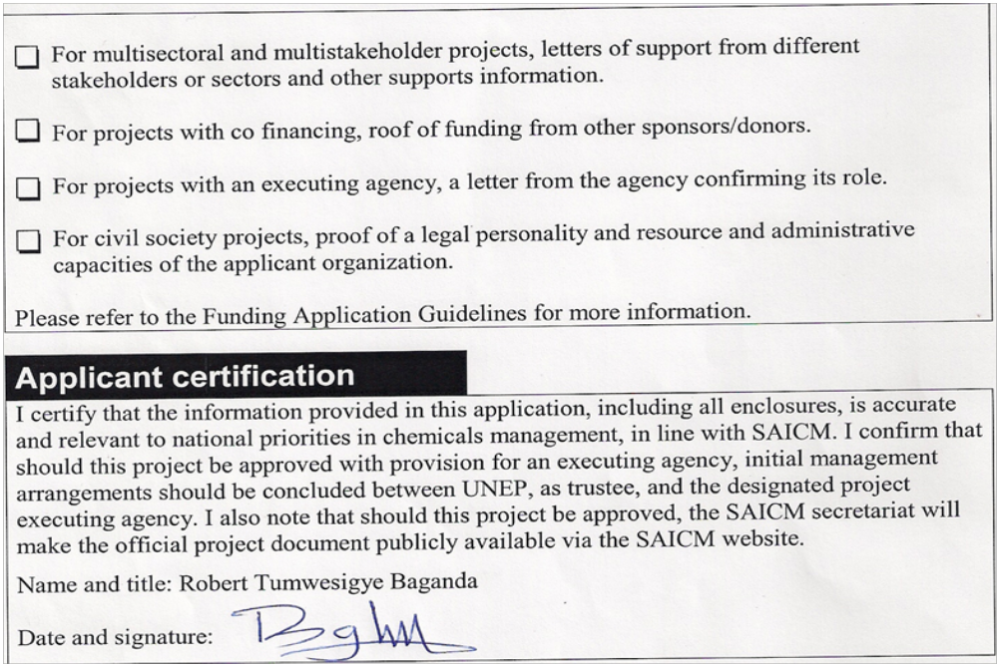

Mwaka V. M. and Tumushabe, J.
The state of Child Labour in Uganda (1996).
Ministry of Labour and Social Welfare Report.

